* Team member names

Ji Lu

Jesse Flores

Xiying Long

* Breakdown of what each person worked on

Ji Lu: question.py, question_answer_database.py, trivia_maze_gui.py, UML Diagram, SRS Document

Xiying Long: room.py, maze.py, player.py, trivia_maze_gui.py, UML Diagram, SRS Document

Jesse Flores: player.py, unit test, trivia_maze_gui.py, UML Diagram, SRS Document

* Total hours contributed by each person on project (refer to Toggl for this information)

Ji Lu: 54 hrs

Jesse Flores: 54 hrs

Xiying Long: 52 hrs

* Discussion of problems you had to overcome

1. Merge conflicts while pulling/pushing from/to remote repo.

* Discussion of shortcomings your project has (if there aren't any state so)

After discussion, we think the following items are shortcomings of our project:

1. Player couldn’t set up the difficulty level of maze themselves. By default, the maze is consist of a 5x5 rooms. The size of maze has to be modified under maze.py.
2. Compatibility between Windows operating system and Mac. When clicking “Instruction” button at the bottom of interface, player who is using Windows operating system will not be able to see full instruction, however, mac users doesn’t have the issue. See picture below.

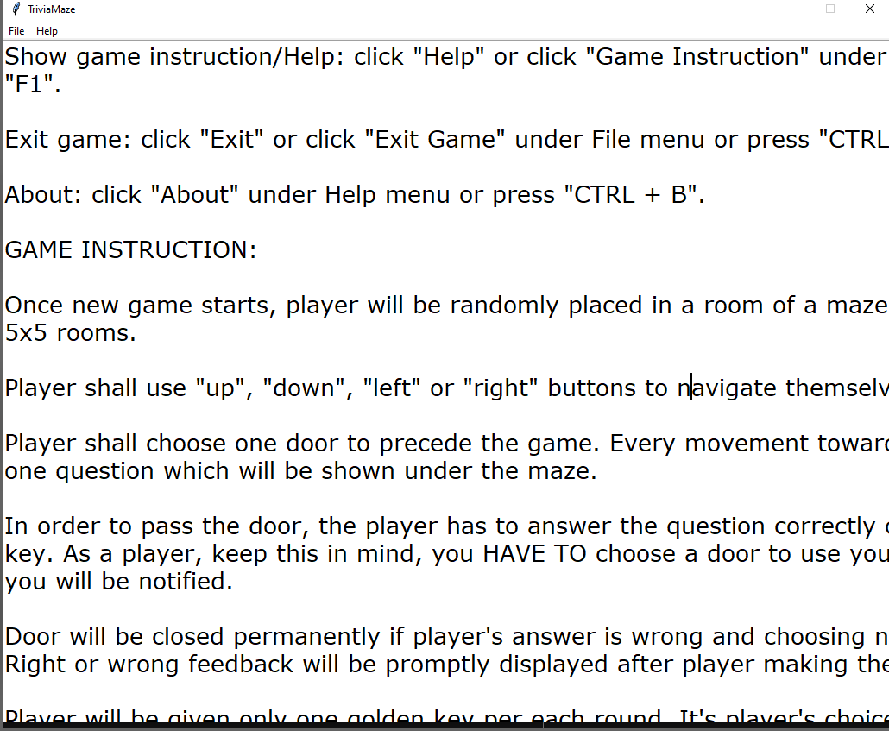

Figure Instruction interface for Windows users

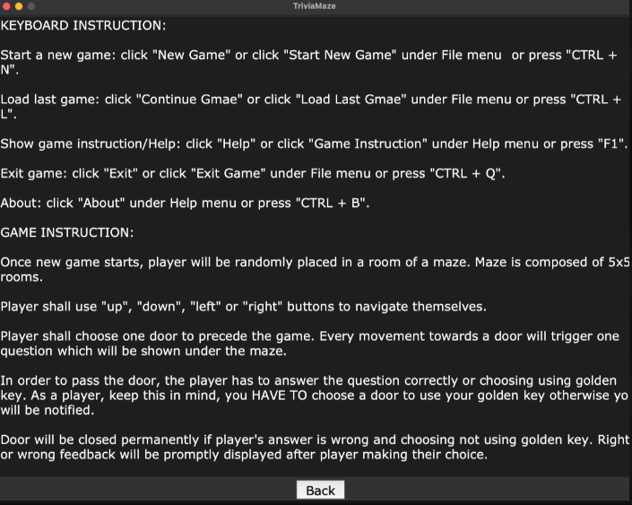

Figure Instruction interface for Mac users

* Discussion of items you feel should be considered for extra credit on project

1. Graphical User Interface (GUI)
2. Golden key features
3. Background music of the program
4. Shortcut key features
5. Feedback message in the program, such as right or wrong feedback after answering the question, loading and saving confirmation message box etc.